**416 Exam Three Review  
Exam: Thursday the Nov 16   
  
Chapter 4:**

**R3: We made a distinction between the forwarding function and the routing function performed in the network layer. What are the key differences between routing and forwarding?**  
Forwarding: Process of getting from router input to output, may not be the entire journey  
Routing: Route that needs to be taken to get from source to destination  
 **R8: What is meant by destination-based forwarding?**  
destination based: traditional way of forwarding, based only on destination IP address

**How does this differ from generalized forwarding (assuming you’ve read section 4.4, which of the two approaches are adopted by Software-Defined Networking)?**  
  
In generalized forwarding, we look at header field values in addition to possibly the destination IP address. SDN uses generalized forwarding  
  
**R9: Suppose that an arriving packet matches two or more entries in a router’s forwarding table. With traditional destination-based forwarding, what rule does a router apply to determine which of these rules should be applied to determine the output port to which the arriving packet should be switched?**  
The longest prefix matching rule will be applied. The entry with the longest match is utilized because it is more specific.  
 **R12: Describe how packet loss can occur at input ports. Can this loss be prevented by increasing the switch fabric speed?**  
Packet loss occurs if the queue size at the input port grows large because of slow switching fabric speed exhausting the router’s buffer space. It can be eliminated if the switching fabric speed is at least n times as fast as the input line speed, n = # of input ports.

**R17: Suppose Host A sends Host B a TCP segment encapsulated in an IP datagram. When Host B receives the datagram, how does the network layer in Host B know it should pass the segment (that is, the payload of the datagram) to TCP rather than to UDP or to some other upper-layer protocol?**  
  
The 8 bit protocol field in the IP datagram contains information about which transport layer protocol the destination host should pass the segment to.   
  
**R20: When a large datagram is fragmented into multiple smaller datagrams, where are these smaller datagrams reassembled into a single larger datagram?**  
  
Reassembled only at final destination. IP header bits are used to ID, and order smaller datagrams back into larger.

**R26: Suppose you purchase a wireless router and connect it to your cable modem. Also suppose that your ISP dynamically assigns your connected device (that is, your wireless router) one IP address. Also suppose that you have five PCs at home that use 802.11 to wirelessly connect to your wireless router. How are IP addressed assigned to the five PCs? Does the wireless router use NAT? Why or why not?**  
  
The wireless router will use a DHCP server to assign local addresses to the five PCs. The router will use NAT to communicate back to the rest of the world over the one ISP assigned IP address.

**P5:** 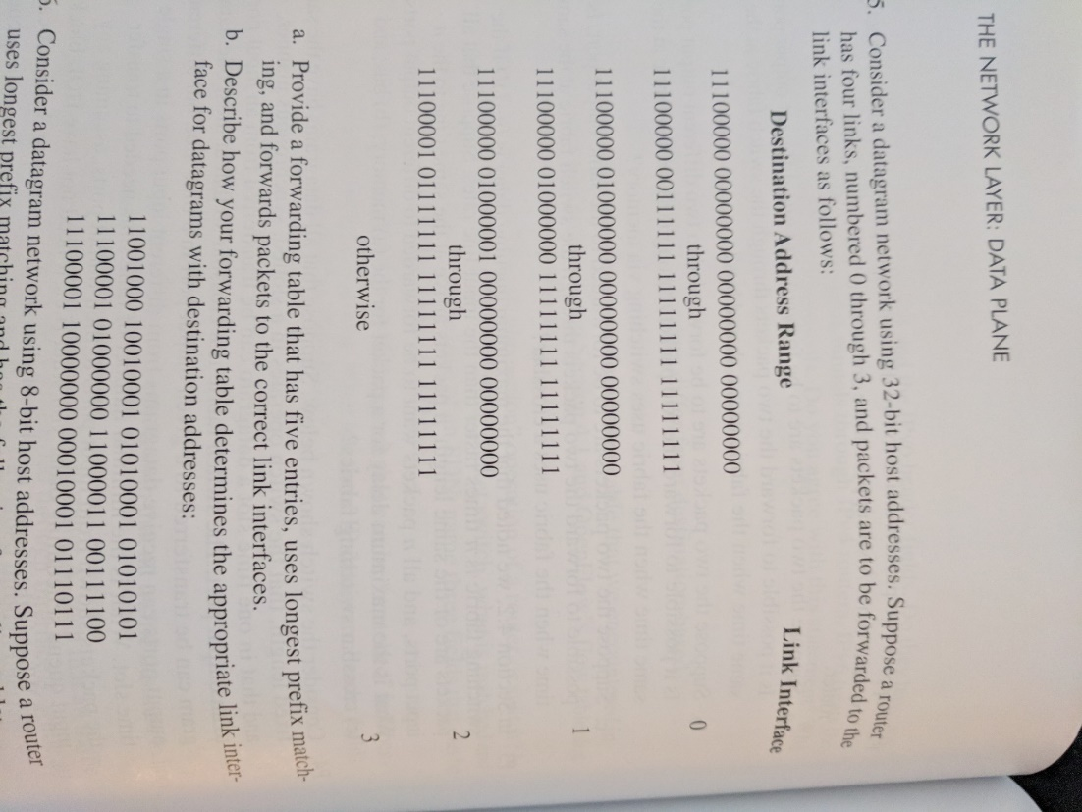  
  
a) Interface:

11100000 00 0  
11100000 01000000 1  
1110000 2  
11100001 1 3  
otherwise 3

b) 1) will go to 3 via otherwise, 11001 as a prefix is not matched at all  
2) will go to 2 via 1110000  
3) will go to 3 via 11100001 1

**P7**: 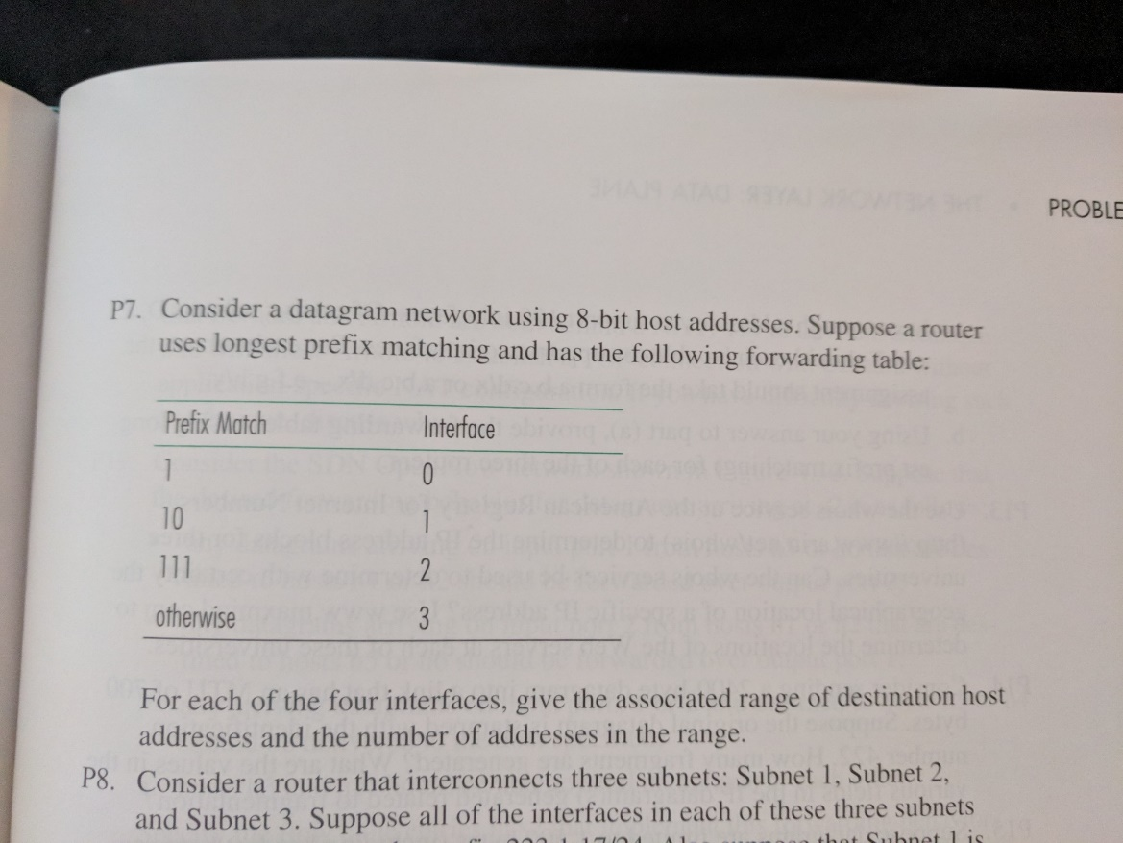  
  
Interface 0 11000000 -> 11011111

Interface 1 10000000 -> 10111111

Interface 2 11100000 -> 11111111

Interface 3 00000000 -> 01111111  
  
**P14: Consider sending a 2400-byte datagram into a link that has an MTU of 700 bytes. Suppose the original datagram is stamped with the identification number 422.**

**How many fragments are generated?**

CEILING OF ( (2400-20) / (700/20) ) = 4

**What are the values in the various fields in the IP datagram(s) generated related to fragmentation?**

All fragments have same ID#. Each of the first three fragments will contain 680 bytes of data + 20 bytes of header, for a total of 700 bytes. Final fragment will contain 340 bytes of data, and 20 bytes of header, for a total of 360 bytes. Each of the first three fragments will have flag = 1. Final fragment will have flag = 0  
  
Offset value = 680/8 = 85. Offsets will be 0, 85, 170, 255.

**P19:   
  
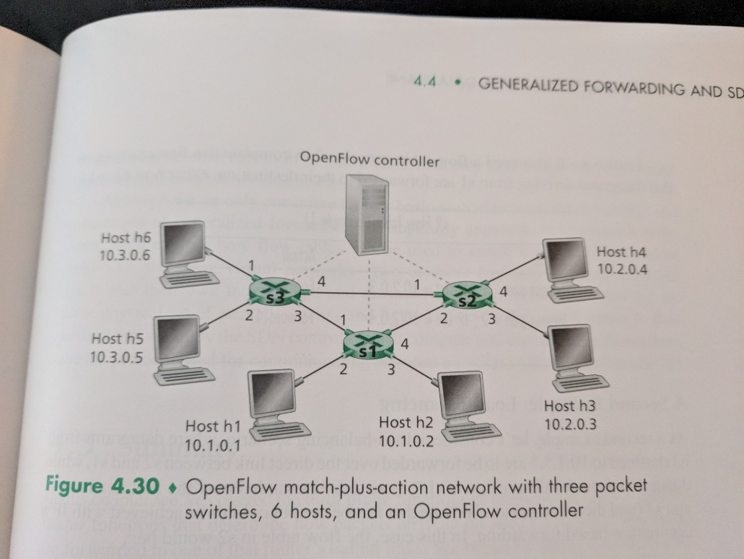  
  
  
  
  
  
Consider the SDN OpenFlow network shown in figure 4.30. Suppose that the desired forwarding behavior for datagrams arriving at s2 is as follows:  
  
any datagrams arriving on input port 1 from hosts h5 or h6 that are destined to hosts h1 or h2 should be forwarded over output port 2;**

**Any datagrams arriving on input port 2 from hosts h1 or h2 that are destined to hosts h5 or h6 should be forwarded over output port 1;**

**Any arriving datagrams on input ports 1 or 2 and destined to hosts h3 or h4 should be delivered to the host specified;**

**Hosts h3 and h4 should be able to send datagrams to each other;**

**Specify the flow table entries in s2 that implement this forwarding behavior.**

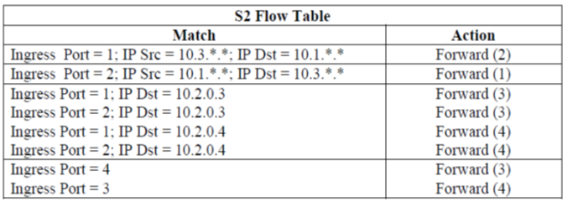

**Chapter 5:**

**R4: Compare and contrast link-state and distance-vector routing algorithms.**  
Link State: (Dijkstras); Link cost known to all nodes  
Distance Vector: (Bellman-Ford); Node only knows the neighbor and the cost of that path, not all knowledge like Link State

**R5: What is the “count to infinity” problem in distance vector routing?**  
Bad news travels slow; When there is a negative change, nodes must “count” iteratively to catch back up to the real node “cost”. If a link dies, however, the nodes will just count forever. To counter this, distance vector routing may utilize a “poisoned reverse” solution wherein a node “lies” to its neighbor that there is no link, i.e. the cost is infinity, avoiding this problem.

**R6: Is it necessary that every autonomous system use the same intra-AS routing algorithm? Why or why not?**  
No. Each autonomous system has a specific admin. autonomy for routing within an autonomous system.  
  
**R7: Why are different inter-AS and intra-AS protocols used in the Internet?**  
Routers are aggregated into local regions known as autonomous systems (AS). All routing WITHIN the same AS is known as intra-AS routing. All of this must use the same protocol. Communication between different AS’s use inter-AS protocols.

**P3:**

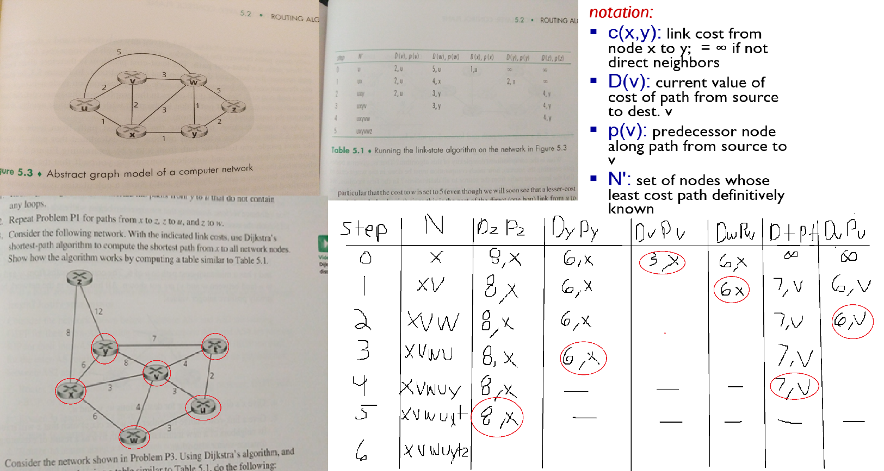

**Also, compute the resulting distance table entries at node x with distance vector routing:**  
  
